# Major Project | 1Stop |CS_KLEEN Security

### Vikash Kumar | [wiryvikash15@gmail.com](mailto:wiryvikash15@gmail.com)

## Problem Statement:

### Make exploitation on Metasploit with different ports.

## Screenshot 2021-09-18 090457

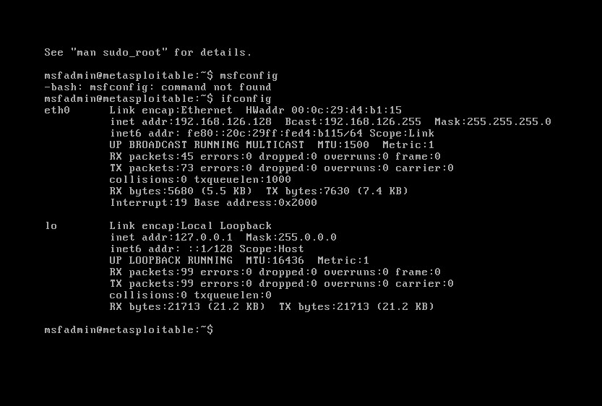

### Telnet Exploitation

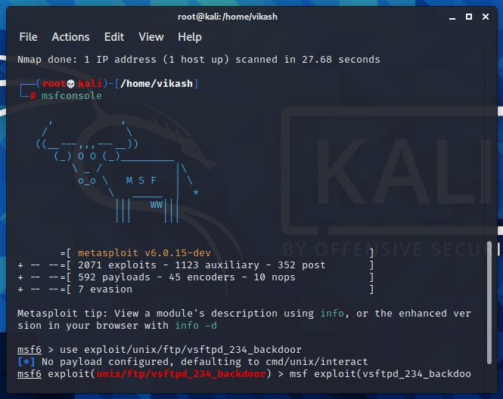

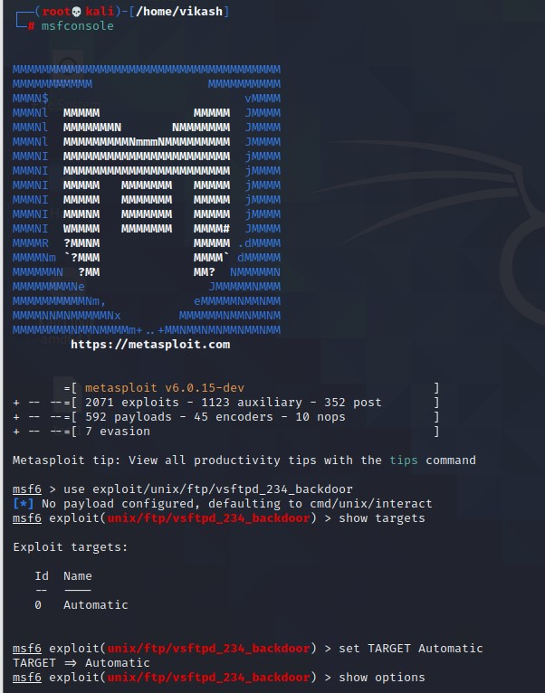

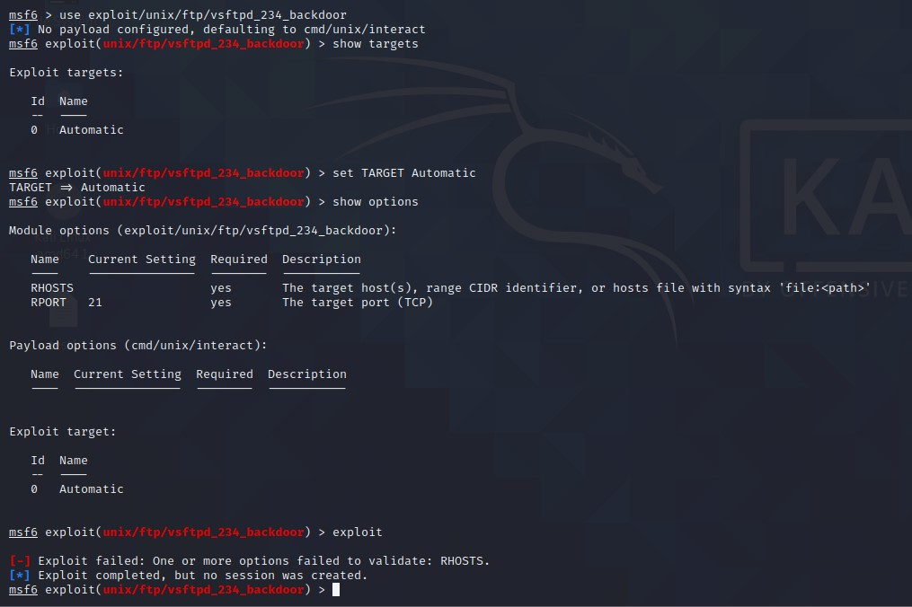

### FTP Exploitation

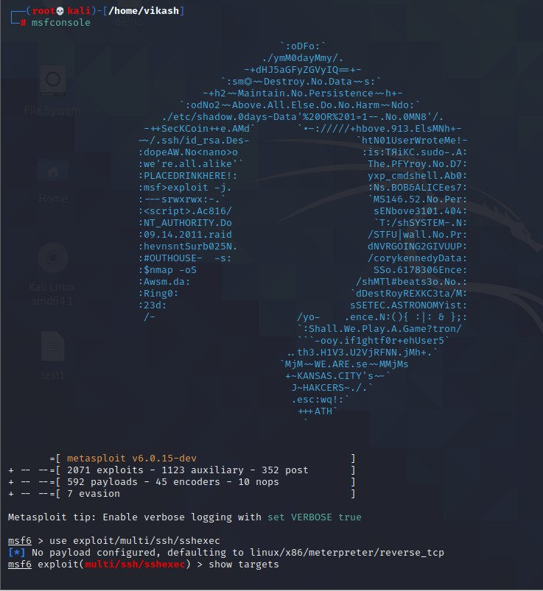

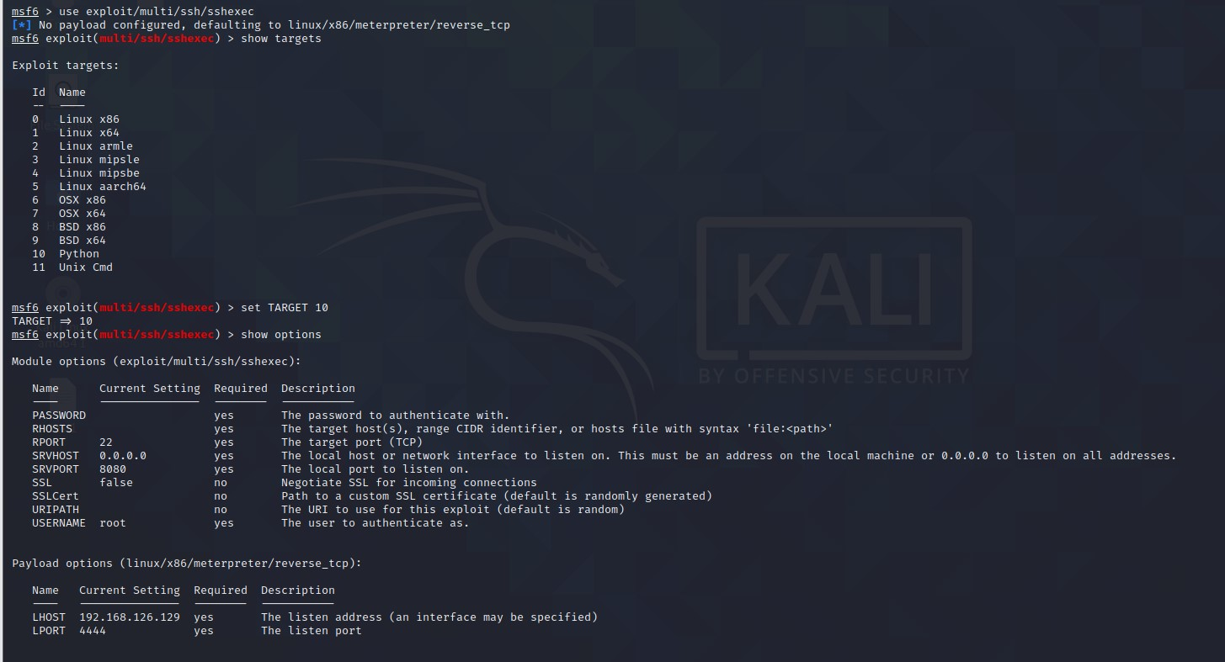

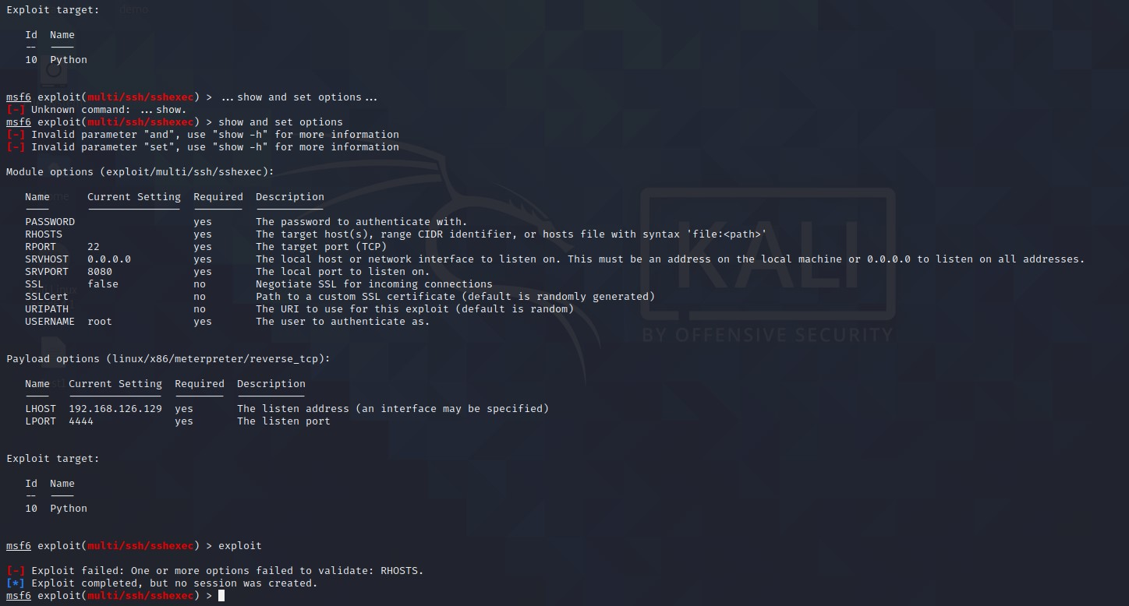

### SSH Exploitation

Screenshot 2021-09-18 092916

